Cost quantile analysis

Lihai

2/10/2021

Contents

Data preparation 1

Modeling 1

Median regression 1

Including median regression Plots 3

75th Quantile regression 3

90th Quantile regression 5

Modeling using LQmm package 7

Random intercept and slope 7

## Data preparation

Trying to run quantile regression mixed model:

treat = c()  
treat[SHUNTRND=="1:MBTS"]=1  
treat[!SHUNTRND=="1:MBTS"]=2  
  
y = cum_cost #response  
x = cbind(1,treat,stage) #design matrix for fixed effects  
z = cbind(1,stage) #design matrix for random effects  
#A median regression  
# median_reg = QRLMM(y,x,z,blind_id,MaxIter = 500)

## Modeling using QRLMM

### Median regression

cost_qt <- QRLMM(y,x,z,blind_id,p=0.5,precision=0.001,MaxIter=100,M=10,cp=0.25,  
 beta=NA,sigma=NA,Psi=NA,show.convergence=TRUE,CI=95)

---------------------------------------------------  
 Quantile Regression for Linear Mixed Model  
 ---------------------------------------------------  
   
 Quantile = 0.5  
 Subjects = 276 ; Observations = 1312   
   
 -----------  
 Estimates  
 -----------  
   
 - Fixed effects   
   
 Estimate Std. Error Inf CI95% Sup CI95% z value Pr(>|z|)  
 beta 1 200185.79 27146.581 146978.49 253393.09 7.37425 0.00000  
 beta 2 35480.44 10268.606 15353.97 55606.91 3.45523 0.00055  
 beta 3 100419.94 6006.443 88647.31 112192.57 16.71870 0.00000  
   
 sigma = 176840.7   
   
 Random effects

ii) Variance-Covariance Matrix   
 z1 z2  
 z1 0.55629 -0.12652  
 z2 -0.12652 0.37127  
   
 ------------------------  
 Model selection criteria  
 ------------------------  
   
 Loglik AIC BIC HQ  
 Value -19029.95 38073.89 38110.15 38087.49  
   
 -------  
 Details  
 -------  
   
 Convergence reached? = TRUE  
 Iterations = 93 / 100  
 Criteria = 0.00222  
 MC sample = 10  
 Cut point = 0.25  
 Processing time = 11.12739 mins

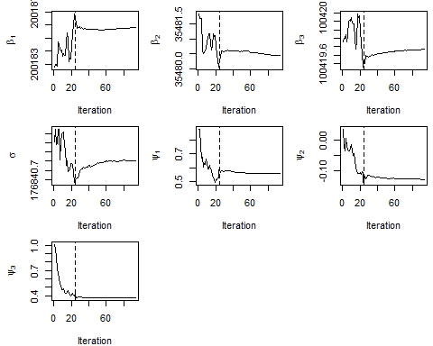

### 75th Quantile regression

cost_qt <- QRLMM(y,x,z,blind_id,p=0.75,precision=0.001,MaxIter=100,M=10,cp=0.25,  
 beta=NA,sigma=NA,Psi=NA,show.convergence=TRUE,CI=95)

---------------------------------------------------  
 Quantile Regression for Linear Mixed Model  
 ---------------------------------------------------  
   
 Quantile = 0.75  
 Subjects = 276 ; Observations = 1312   
   
 -----------  
 Estimates  
 -----------  
   
 - Fixed effects   
   
 Estimate Std. Error Inf CI95% Sup CI95% z value Pr(>|z|)  
 beta 1 561618.54 34388.073 494217.91 629019.1591 16.33178 0.0000  
 beta 2 -25128.35 12926.460 -50464.21 207.5078 -1.94395 0.0519  
 beta 3 118545.64 7881.838 103097.23 133994.0389 15.04035 0.0000  
   
 sigma = 193988.9   
   
 Random effects   
   
   
 ii) Variance-Covariance Matrix   
 z1 z2  
 z1 0.52215 0.01329  
 z2 0.01329 0.41751  
   
 ------------------------  
 Model selection criteria  
 ------------------------  
   
 Loglik AIC BIC HQ  
 Value -19513.08 39040.15 39076.41 39053.75  
   
 -------  
 Details  
 -------  
   
 Convergence reached? = FALSE  
 Iterations = 100 / 100  
 Criteria = 0.00437  
 MC sample = 10  
 Cut point = 0.25  
 Processing time = 11.90188 mins

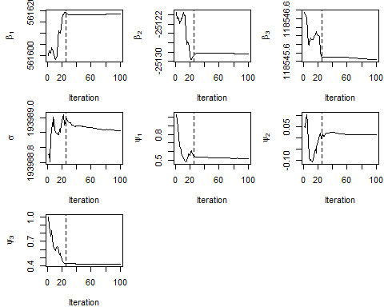

### 90th Quantile regression

cost_qt <- QRLMM(y,x,z,blind_id,p=0.9,precision=0.001,MaxIter=100,M=10,cp=0.25,  
 beta=NA,sigma=NA,Psi=NA,show.convergence=TRUE,CI=95)

---------------------------------------------------  
 Quantile Regression for Linear Mixed Model  
 ---------------------------------------------------  
   
 Quantile = 0.9  
 Subjects = 276 ; Observations = 1312   
   
 -----------  
 Estimates  
 -----------  
   
 - Fixed effects   
   
 Estimate Std. Error Inf CI95% Sup CI95% z value Pr(>|z|)  
 beta 1 319620.5 32577.059 255769.5 383471.6 9.81121 0  
 beta 2 357825.0 17127.137 324255.8 391394.2 20.89229 0  
 beta 3 174206.6 7155.196 160182.4 188230.8 24.34687 0  
   
 sigma = 144164.2   
   
 Random effects   
   
   
 ii) Variance-Covariance Matrix   
 z1 z2  
 z1 0.57312 -0.09840  
 z2 -0.09840 0.68261  
   
 ------------------------  
 Model selection criteria  
 ------------------------  
   
 Loglik AIC BIC HQ  
 Value -20096.07 40206.15 40242.4 40219.74  
   
 -------  
 Details  
 -------  
   
 Convergence reached? = FALSE  
 Iterations = 100 / 100  
 Criteria = 0.00433  
 MC sample = 10  
 Cut point = 0.25  
 Processing time = 11.7537 mins

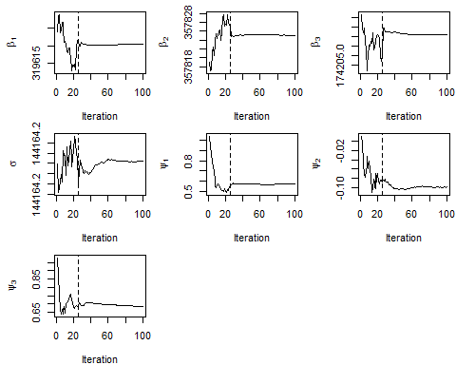

## Modeling using LQmm package

### Random intercept and slope

# Random slope model  
cost.lqmm2 <- lqmm( y ~ SHUNTRND*stage, random = ~ 1 + stage, group = blind_id, tau = c(0.5,0.75,0.9), data = cost, control = lqmmControl(method = "df", UP_max_iter = 800))  
summary(cost.lqmm2)

Call: lqmm(fixed = y ~ SHUNTRND * stage, random = ~1 + stage, group = blind_id,   
 tau = c(0.5, 0.75, 0.9), data = cost, control = lqmmControl(method = "df",   
 UP_max_iter = 800))  
   
 tau = 0.5  
   
 Fixed effects:  
 Value Std. Error lower bound upper bound Pr(>|t|)  
 (Intercept) 390395.2 61116.4 267577.2 513213 5.894e-08  
 SHUNTRND2:RV to PA 96715.1 83106.2 -70293.0 263723 0.25016  
 stage 108833.4 54926.5 -1545.6 219212 0.05317  
 SHUNTRND2:RV to PA:stage 14911.6 61628.3 -108935.1 138758 0.80982  
   
 (Intercept) ***  
 SHUNTRND2:RV to PA   
 stage .   
 SHUNTRND2:RV to PA:stage   
 ---  
 Signif. codes: 0 '***' 0.001 '**' 0.01 '*' 0.05 '.' 0.1 ' ' 1  
   
 tau = 0.75  
   
 Fixed effects:  
 Value Std. Error lower bound upper bound Pr(>|t|)  
 (Intercept) 324028.6 64998.6 193409.0 454648 8.14e-06  
 SHUNTRND2:RV to PA 125304.6 65883.0 -7092.3 257701 0.063068  
 stage 333950.5 95783.7 141465.9 526435 0.001043  
 SHUNTRND2:RV to PA:stage 19994.6 44332.9 -69095.8 109085 0.653972  
   
 (Intercept) ***  
 SHUNTRND2:RV to PA .   
 stage **   
 SHUNTRND2:RV to PA:stage   
 ---  
 Signif. codes: 0 '***' 0.001 '**' 0.01 '*' 0.05 '.' 0.1 ' ' 1  
   
 tau = 0.9  
   
 Fixed effects:  
 Value Std. Error lower bound upper bound Pr(>|t|)   
 (Intercept) 380046 168132 42173 717919 0.028274 *   
 SHUNTRND2:RV to PA 108108 124736 -142559 358774 0.390336   
 stage 490422 158596 171712 809133 0.003275 **  
 SHUNTRND2:RV to PA:stage 17349 129634 -243161 277858 0.894087   
 ---  
 Signif. codes: 0 '***' 0.001 '**' 0.01 '*' 0.05 '.' 0.1 ' ' 1  
   
 AIC:  
 [1] 36866 (df = 7) 37209 (df = 7) 37427 (df = 7)